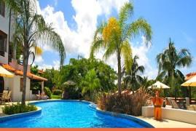
VACATION PLANNER
TIMES: | SUNDAY | MONDAY | TUESDAY | WEDNESDAY | THURSDAY | FRIDAY | SATURDAY
BREAKFAST  7:30 AM - 10:00 AM | Daily Breakfast at La Salsa Restaurant
Daily | Beach & Speightstown Shuttle Service - Book at Front Desk  Leave at 9:00 & 10:00AM, 12:00, 3:00 & 5:10 PM. Return at 10:10AM,12:10, 3:10 & 5:15 PM.
Daily | Visit www.barbadostraveller.com or the Front Desk for all your Tours, Activities, Restaurants & Island Information
10:00 AM | Relax on  the Beach | Rent a car and explore the island | Gully Walk - Meet in Lobby | 4 x 4 Jeep Safari  *Special rates apply* | Gully Walk - Meet in Lobby | Glass Bottom Boat  - Meet at Lobby | Lounge by the pool
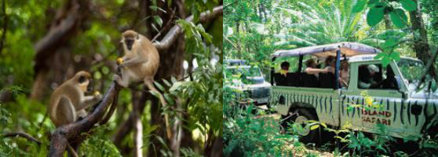
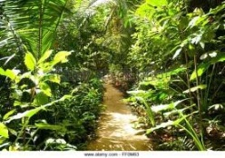
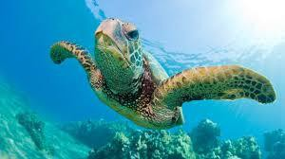
11:00 AM | Daily Property Tour - Meet at Reception
LUNCH  12:00 PM - 2:30 PM | Daily Lunch at La Salsa or Poolside - Snack menu is also available from 3PM to 6PM
The Gym is available 24 hours  Evening attire: No short pants, sleeveless shirts  or hats accepted in the La Salsa Restaurant & Bar for evening dinner. | Mixology Session  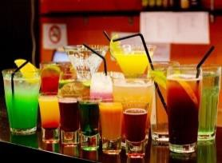  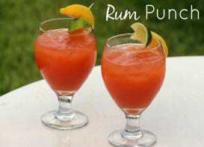  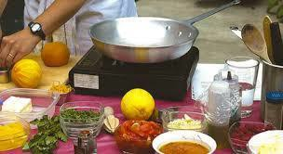  Pool Bar | Manager’s  Cocktail Party | Rum Tasting Session  Main Bar | Cooking Demonstration La Salsa |  | Oistins  Excursion  Minimum of 4pp
 | 4:00 PM | 6:00 PM | 4:00 PM | 4:00 PM |  | 6:00 PM BDS$80 PP
Afternoon Tea  4:00 PM – 5:00 PM | Daily Ice-Cream Afternoon Tea - serve in the Green Monkey Lounge
DINNER  6:30 PM - 9:30 PM | Sandy's Chattel  Bar & Restaurant | Pool Side  (weather permitting) | La Salsa  Restaurant | Sandy's Chattel  Bar & Restaurant | Pool Side  (weather  permitting) | La Salsa  Restaurant | Pool Side  (weather permitting)
7:00 PM Entertainment | _ | Live Music | _ | _ | Live Music | _ | Live Music
OTHER THINGS TO DO * SPECIAL EVENTS * INFORMATION * OTHER THINGS TO DO * SPECIAL EVENTS * INFORMATION
Visit the Sundry Shop in the Lobby |  | Meet Damian for an Island Tour |  | Visit Alyssa in the Spa |  | Book a Private  Dining Experience

